Web 3.0, Data Analytics and Artificial Intelligence
Final Exam Report

UNIVERSITY OF JAKARTA INTERNATIONAL

Muhammad Galih Desta Haryadi Putra(241103110104)
Pc Health Monitoring System

Introduction
Artificial Intelligence is very well known and used in most user activities and each time new innovation of artificial intelligence keeps coming and one of it is called Local Ai, Unlike standard cloud-based AI tools that process data on remote servers via the internet, a Local AI model is installed and executed directly on a user's physical device. This ensures absolute data privacy and can be used offline. The project i made utilized gemma4:e2b, a lightweight edge variant from Google DeepMind's Gemma 4 family which required only just 1.5 GB of memory and running efficiently on a standard laptop CPU without a dedicated graphics card, the model capably interprets structured data, evaluates contextual logs, and generates natural language text. The model is managed via Ollama, an open-source runtime environment that hosts the AI as a local background service. Python communicates with Ollama locally via HTTP requests on the same machine, meaning no user data ever leaves the local system architecture.

With AI, everyone including myself can automate activities and generate information effectively, it can smoothen the user activities and solves some complex technical problems. One of the practical problems a locally running language model can solve is PC performance health monitoring. A computer's health is determined by how well its core components: processor, memory, storage, and operating system are functioning at any given time. When one of these components starts struggling, it gives different effects through the rest of the system: applications slow down, files take longer to open, the machine becomes unresponsive, or programs crash unexpectedly.
Most users only notice these symptoms after the fact. There is no built-in tool that watches all of these indicators at once, interprets them together, and explains in plain language what is happening and what should be done about it. This is the problem my project solves. By combining live system metrics with Windows error event data and feeding it all to a locally running AI model, the project produces automatic, real-time health summaries entirely offline, entirely on-device, and entirely without any manual effort from the user.
The result is a Python program that runs every 30 seconds in the background, silently collecting data, sending it to Gemma, and delivering the AI's interpretation to the user through both a log file and a popup window on screen.
Understanding a computer's health depends on knowing which signals to watch. The four indicators this project monitors: CPU usage, RAM consumption, disk space, and Windows Event Log errors are the most reliable real-time signals of how a Windows PC is performing. Together they give a picture that no single indicator can provide on its own.
Ollama and gemma4:e2b are what turn these signals into something meaningful. Python is for me to connect all the moving parts: collecting the data, formatting it, sending it to the model, and delivering the response in a visually stunning pop up. A virtual environment ensures that the project's dependencies are isolated and the program runs consistently regardless of what else is installed on the machine. The sections after this explain how each of these pieces fits into the larger picture.

Relevancy To Unit Material

This project is based on four specific performance indicators that collectively represent the health of a Windows PC. Each one maps directly to a component of the python code.

Indicator | How it is collected | Insight Provided
CPU Usage (%) | psutil.cpu_percent() | How hard the processor is working. Consistently high values suggest a runaway process or system overload.
RAM Usage (%) | psutil.virtual_memory() | How much memory is in use. When near full, Windows starts using the disk as overflow, causing slowdowns.
Disk Usage (%) | psutil.disk_usage('C:\') | How full the C drive is. A nearly full disk degrades performance and risks data loss.
Window Logs | PowerShell Get-WinEvent  -System Log  -Application | Critical and Error events from the System and Application logs: hardware failures, driver crashes, service errors that metrics alone cannot detect.
These four indicators are the minimum viable set for a meaningful health assessment. The first three are quantitative because they tell you how much, although it isn't enough to determine whether the pc is fine or not. The fourth is qualitative because it tells you what went wrong at the system level. A disk at 45% usage looks perfectly healthy in a metric alone, but if the Windows System log is simultaneously recording Event ID 51 (a disk read error), the disk may be in the early stages of failure. Only by reading both together can that conclusion be reached.
Since the indicator has already been found, it is being processed and provided with the indicator information by python, but for this project I applied Local Ai with the Ollama Ai and gemma4:e2b.
What can the local Ai provide for this project?
The unit introduced AI as a tool that goes beyond data collection but it adds intelligence to raw information. In this project, gemma4:e2b running through Ollama provides three things that no amount of metric collection alone can deliver.
First, it provides interpretation. The model reads the four indicators as a structured prompt and determines what their combined state means for the health of the machine. It does not simply report a number, it explains what that number indicates in context.
Second, it provides recommendations. Every response the model generates ends with one concrete action the user can take. This makes the output immediately useful rather than just informative.
Third, it provides accessibility. The output is in plain language. A user does not need to know what Event ID 7034 means to understand the model's response: "A service crashed and restarted itself, open Task Manager and check for any services using abnormally high memory." That sentence is understandable to anyone, regardless of their technical background.”
Problem Solving
The problem this project addresses is specific: most Windows users have no practical way to know whether their computer is genuinely healthy at any given moment. The tools that exist to check are: Task Manager, Resource Monitor, Event Viewer where each shows one piece of the picture in isolation. Task Manager shows live CPU, RAM, and disk usage, but gives no indication of why those numbers are what they are. Event Viewer records every system error, but it requires manually navigating through thousands of events and knowing which ones actually matter. Neither tool explains what its data means, and neither tool combines all relevant signals into a single, understandable output.
The result is that users either ignore their PC's health entirely until something breaks, or they try to understand raw data they are not equipped to understand. Neither outcome is good, especially in a context where the laptop is the primary device for work and study.
So in order to solve this solution, the tools I used are python which include venv and Local Ai which is Ollama Ai with the gemma4:e2b model.
- How the Ai model and ollama solve it
Ollama use gemma4:e2b as a local HTTP API on port 11434. This means Python can send a request containing the collected health data and receive the model's response in the same way a website sends and receives data, except entirely on the local machine and run by Visual Studio Code. No internet is involved, and nothing leaves the device.
The model receives a structured prompt that looks like this: CPU is at a certain percentage, RAM is at a certain level, Disk is at a certain level, and these specific Windows errors were recorded in the last 5 minutes. It then generates a 2-to-3-sentence response that summarizes the overall health of the machine, highlights any concerning indicators (including specific Event IDs if relevant), and recommends one concrete action. This output is logged and displayed automatically, with no human involvement in the analysis step.
This is the core contribution of the AI in this project. It takes multiple raw data points that require expertise to interpret individually and produces a single, actionable, plain-language output that any user can understand and act on.

- Role Of Python & Vnev
I use python for the sake of connecting the data, access, function of the entire project. It does not do the AI analysis itself because that is Gemma's job. What Python does is collect every piece of data the AI needs, format it correctly, deliver it to the model, and handle everything that happens with the response.
The specific roles Python plays are: reading CPU, RAM, and disk data using the psutil library:p; calling PowerShell through subprocess to retrieve Windows Event Log entries and parsing the JSON output; building the structured prompt that gives the AI model the right context; communicating with Ollama using the ollama Python library; running the monitoring loop and the manual prompt listener at the same time using threading; writing the log file; and generating the popup window by writing a PowerShell Windows Forms script and launching it as a separate process.
The virtual environment (.venv) addresses a practical but important problem: Python packages installed for one project can conflict with packages installed for another, or with the system's default Python installation. By isolating all of this project's dependencies — specifically ollama and psutil — inside a .venv folder, the project runs consistently on any Windows machine where the venv is set up. This is also essential for Windows Task Scheduler, which launches scripts at startup without activating any environment. Pointing the scheduler directly at the venv's Python executable ensures the correct packages are always available, regardless of how or when the script is launched.

Real-World Example

There is an important question for my project which is: does it actually need an AI? is using python enough? It can read system metrics, pull Windows Event Log data, format everything into a clean report, and display it in a colored terminal or a popup window. That is all achievable with pure Python and no AI model at all.
But there is a fundamental limit to what Python can do with that data. Python can tell you what the numbers are. It cannot tell you what the numbers mean. this is output from a pure Python monitoring script in my project:

CPU: 76% | RAM: 79% | Disk: 62% | Event ID 7034 (System — Critical)

A system administrator or an IT student might read this and immediately know that 79% RAM combined with a service crash (Event ID 7034) is a warning sign that a background process is leaking memory. But most users including technically educated students like me who are not specifically trained in Windows system administration would not know what to do with this output. They would see numbers and an Event ID that means nothing to them.
Now compare that to the AI's output for the same data:
"RAM usage is high at 79%, and the logged service crash (Event ID 7034) suggests a background process may be consuming excessive memory and becoming unstable. Open Task Manager, sort by memory usage, and end any processes you do not recognise or that appear to be using unusually large amounts of RAM."
This output is immediately understandable, especially for me in my opinion. It identifies the problem, connects the metric to the event log entry, and tells the user exactly what to do. No technical background is required to act on it. The gap between data that exists and guidance that is usable are what the AI fills, and what Python alone cannot.

Open-source tools like Open Hardware Monitor do the data collection side well and they read CPU temperatures, fan speeds, voltages, and usage in real time. But they have no interpretation layer. They display numbers. A user who sees their CPU temperature at 87 degrees Celsius and does not know whether that is normal for their specific processor is no better off than a user who has never opened the tool at all.
Microsoft itself has recognised this gap. Windows Security Center and Windows Defender both use on-device AI models to monitor system behaviour and translate what they find into plain-language notifications and recommendations. When Defender detects unusual activity, it does not show users a raw event log entry, because it says "a threat was detected on your device" and tells them what to do. The concept this project implements: local AI reading system data and producing plain-language summaries is the same concept Microsoft uses for security monitoring, applied here to general performance health.

Making the Output Understandable to Everyone is the main objective of the project,
A key design goal of this project is that its output should be useful to any user, not just technically trained ones. The popup window that appears every 90 seconds shows the health summary in plain language, with colour-coded metrics (green for healthy, orange for moderate, red for high). But more importantly, it also allows the user to ask follow-up questions directly inside the popup through the Ask Gemma input box.
This means that if a user sees an unfamiliar term or event in the summary such as "Event ID 51" or "disk paging error" and they do not need to leave the popup, open a browser, and search for an explanation. They can type "what does Event ID 51 mean?" directly into the Ai and receive an immediate, plain-language answer from the model. This makes the tool self-explanatory and interactive in a way that no static monitoring script can replicate. Below is the pop up image that shows the user their pc performance summary:
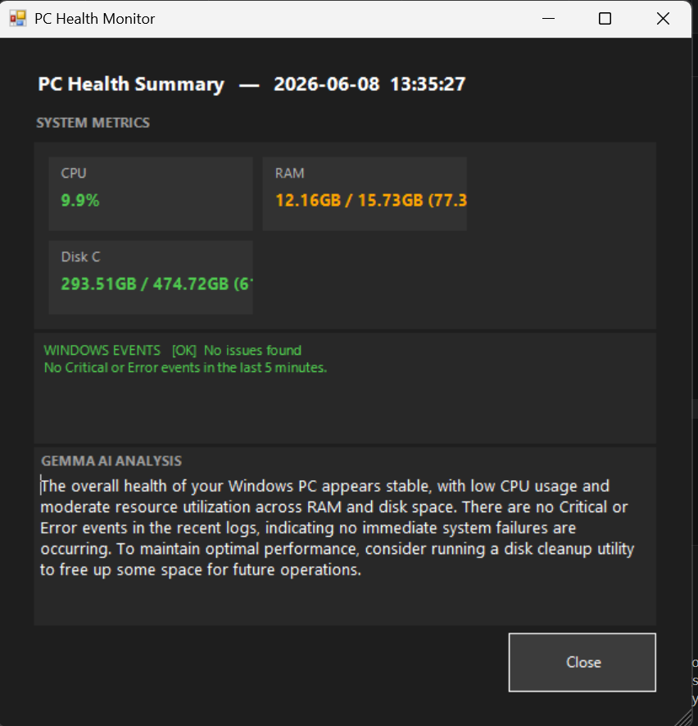
This is the pop-up menu, it gives the information of the indicators in an unique and easy to understand font and colour with also a useful insight and analysis from the Ai, it also shows the Date & Time.

Excluding this, my project also has another feature like I explained before which is the interactive Gemma Ai in the project to answer all of our questions, especially about the output.

Ai use case example:

The user asked "What does Event ID 51 mean and why is my RAM usage at 79%?"
The Ai will generate the answer like:
"Event ID 51 is a system warning indicating a generic paging error during a data write or read operation to your storage drive. This usually means your physical drive or its controller took too long to respond to an operating system command.
Your RAM usage is high at 79% because your physical memory is nearing full capacity, forcing Windows to use your storage drive as overflow memory (known as a pagefile). Because your system is actively writing memory overflow onto a struggling or busy disk, it is triggering the Event ID 51 slowdowns.
Recommended Action: Close resource-heavy browser tabs or applications running in the background to lower your RAM usage below 70%. This will minimize pagefile dependency and reduce physical strain on your hard drive."

Future Work
My project is still limited by certain things: It can only use Ai in terminal, pop up took so long to appear(device reason), Pop-up only appear for 20 seconds, so there is many room for improvement like:

- Interactive Ai in pop-up + Longer pop-up display

My current project currently uses Ai but can only be used on terminal, additionally, the pop up only appears for 20 seconds before it vanishes which can be an inconvenience for the user and myself due to not having enough time to read all the pop-up summary and information. This project could potentially have a longer pop-up being displayed while having an interactive Ai in each pop-up so the Ai can give answers based on the displayed pop-up information and insight.

- Network Health
Connectivity issues like packet loss, DNS failures, unstable Wi-Fi directly affect the experience of using a laptop for work and study, but they do not appear in CPU, RAM, or disk metrics at all. Adding basic network health checks to each monitoring cycle would give the AI the ability to identify and explain network-related performance issues, which are among the most common complaints from everyday laptop users.

- More Access To Laptop Data
While the current project system establishes a solid baseline by monitoring CPU, RAM, disk space, and critical Windows events, expanding its data collection to include hardware temperatures, predictive warning logs, and security events would significantly enhance the AI's diagnostic accuracy and completeness.
Integrating temperature readings for the CPU, GPU, and storage drives provides crucial visibility into physical hardware risks like thermal throttling, which usage percentages alone can conceal. Furthermore, capturing specific warning-level system logs (Event IDs 129, 153, and 219) shifts the application from a reactive reporter to a predictive diagnostic tool capable of flagging early storage drive failures weeks in advance. Finally, incorporating security event logs (Event IDs 4625 and 4740) scales the system from a pure performance monitor into an automated cybersecurity awareness tool that instantly alerts users to unauthorized access attempts or suspicious account lockouts.

References

Ai Conversation. https://claude.ai/share/d3081c30-26fa-435c-b886-c13cd8ed964e
Bswen Tech. (2026, April 3). Gemma 4 Model Variants Explained: Deep Dive into Edge Variants. Diambil dari https://docs.bswen.com/blog/2026-04-03-gemma-4-model-variants-explained/
Glarysoft. (2026). Why is Windows Network Performance Tuning Important for Your Windows PC and How to Manage It. Diambil dari https://www.glarysoft.com/how-to/why-is-windows-network-performance-tuning-important-for-your-windows-pc-and-how-to-manage-it-2/
Open Hardware Monitor. (2026). Open Hardware Monitor: Core Hardware Temperature, Fan Speed, Voltages, and Load Monitor Tool. Diambil dari https://openhardwaremonitor.org/
Support Your Tech. (2026). How to Check Event Logs in Windows 11: A Step-by-Step Guide. Diambil dari https://www.supportyourtech.com/tech/how-to-check-event-logs-in-windows-11-a-step-by-step-guide/

